

CLIENT: Kgwebo It services
Client 1d: cl-143
Location: Klerksdorp, North west , south Africa
INDUSTRY: TECHNOLOGY
NEWORK ADDRESS: 10.54.0.0/16
Networking challenge: static routing
Lecture: Dr lugayizi
STUDENT NAME; Ofemetse PASSION TAGANE
MODULE: CMPG325
STDENT NUMBER: 46842918
DUE DATE ; 16 October 2026

This document outlines the computer network system design and implementation for KGWEBO IT SERVICES. The objective is to ensure effective planning, delivery and continual improvement for KGWEBO IT SERVICES.

INTRODUCTION
Background
Computers networks allow organizations to share data, link teams and access shared resources. A well-designed network boosts overall communication, increases resource accessibility and improve the management of an organization’s IT infrastructure
Kgwebo IT services needs a network that links computers across its departments and have a reliable access to shared resources The network should balance inter-network communication while practicing strict security rules for server access according to KGWEBO IT Services. A CISCO PACKET TRACER was used for a simulated network; the proposed topology was designed before its configuration and performance were assessed.
Aim of this project
The aim of this project is to design, build, configure, secure and evaluate a multi-router network for KGWEBO IT Services using CISCO PACKET TRACER. The network should use a static routing across all its departments and have an access control to the central application/file server.
Project objectives.
- Develop an IP addressing plan using the given block from the client 10.54.0.0/16
- Configure the IP Addresses and subnet masks on end-devices and routers according to the IP addressing plan (the proposed design)
- Set Up the application file/server
- Configure the static routes for departmental networking
- Use Access Control List to allow only authorised departments
- Test and verify the network set up
- To document the configuration, testing evidence and the challenges

- PROPOSED DEPARTMENTS
The proposed departments for nature of KGEWBO IT SERVICES are these; IT support, Software Development and Administration. Two departments’ PCs are assigned to each department to demonstrate end-user connectivity within the Packet Tracer Simulation.
Table below shows the representation of the departments
Department | Representative
Administration | PC1, PC2
IT Support | PC3, PC4
Software Development | PC5, PC6

The following table shows names and the total number of devices used for the project simulation and are not intended to represent the actual KGWEBO IT SERVICES actual number of physical equipment
Device type | Naming | Total
PCs | PC1 – PC6 | 6
Server | SERVER1 | 1
Routers | R1, R2, R3 | 3
Switch | SW1 ,SW2 ,SW3 | 3

DEPARTMENTAL NETWORK STRUCTURE

Department | Network Address | Gateway | Connected PCs
Server Network | 10.54.40.0/24 | 10.54.40.1 | Server
Admin | 10.54.10.0/24 | 10.54.10.1 | PC1, PC2
IT Support | 10.54.20.0/24 | 10.54.20.1 | PC3, PC4
Software Dev | 10.54.30.0/24 | 10.54.30.1 | PC5,PC6

ROUTER CONNECTIONS
The following table explains the router-to-router links
IP ADDRESS | CONNECTION
10.54.1.1-10.54.1.2 | R1-R2
10.54.2.1-10.54.22 | R2-R3
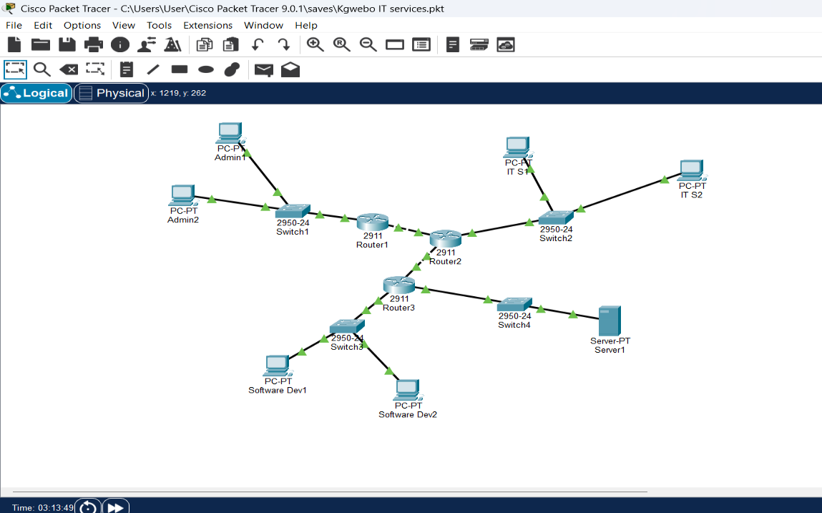

Figure 1 Implemented network topology
IP ADDRESSING IMPLEMENTATION
Device addressing
The table below shows the devices and IP address of the networking system
Device | IP address | Subnet Marks | Gateway
Server1 | 10.54.40.10 | 255.255.255.0 | 10.54.40.1
R1 | 10.54.10.1 | 255.255.255.0 | -
PC1 | 10.54.10.10 | 255.255.255.0 | 10.54.10.1
PC2 | 10.54.10.11 | 255.255.255.0 | 10.54.10.1
R2 | 10.54.20.1 | 255.255.255.0 | -
PC3 | 10.54.20.10 | 255.255.255.0 | 10.54.20.1
PC4 | 10.54.20.11 | 255.255.255.0 | 10.54.20.1
R3 | 10.54.30.1 | 255.255.255.0 | -
PC5 | 10.54.30.10 | 255.255.255.0 | 10.54.30.1
PC6 | 10.54.30.11 | 255.255.255.0 | 10.54.30.1
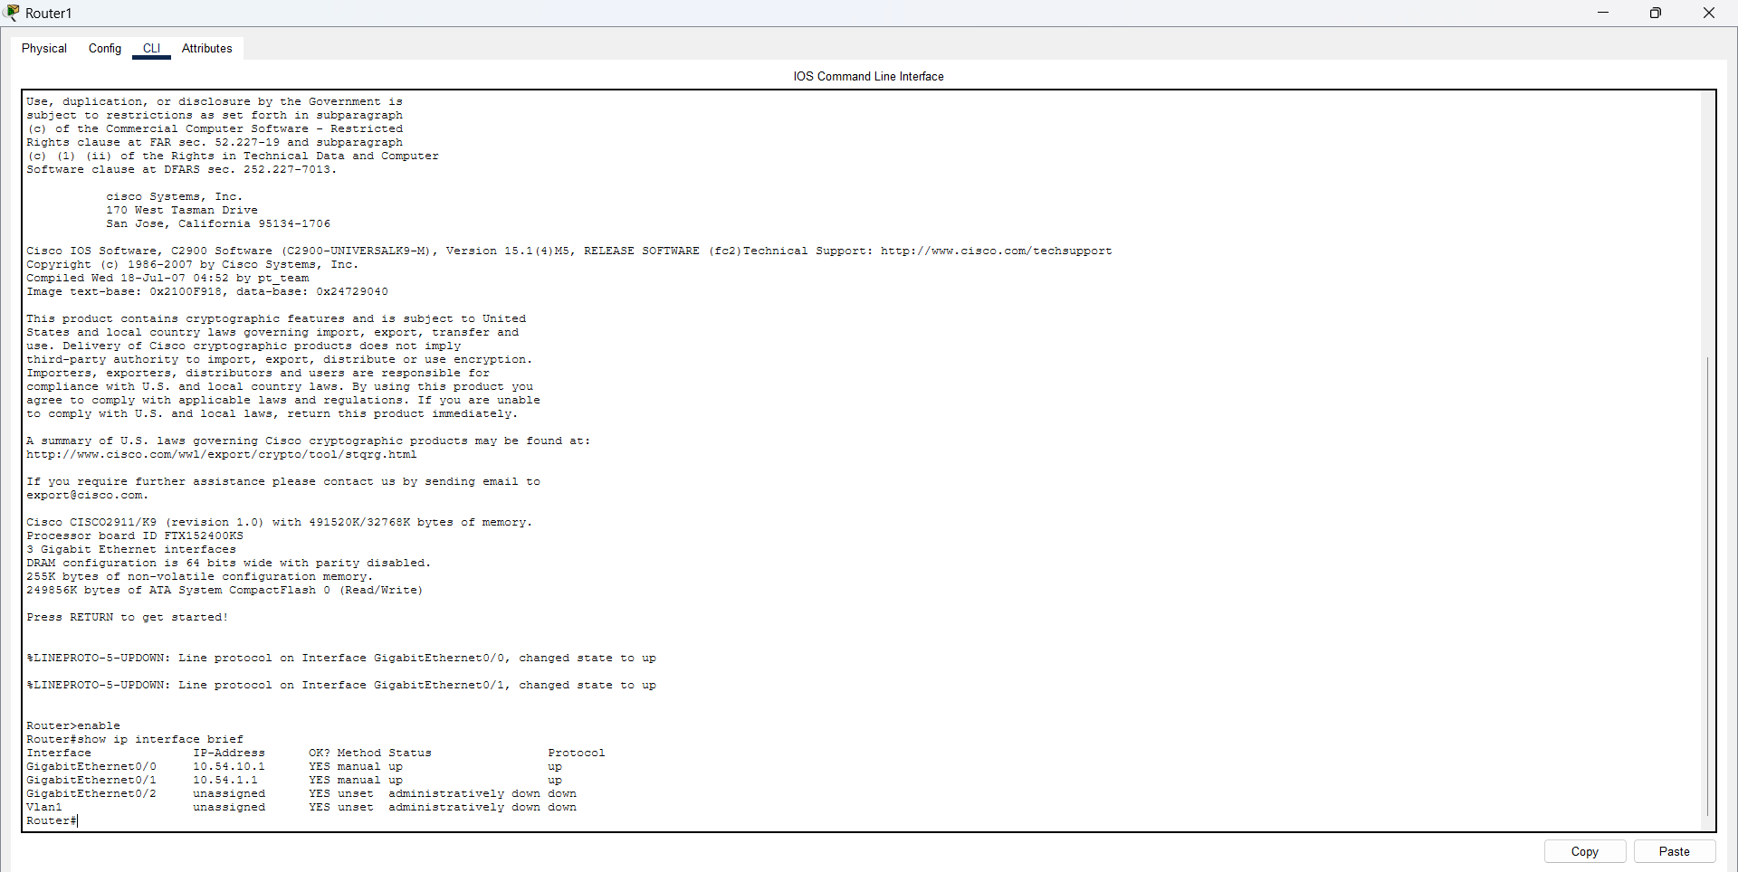

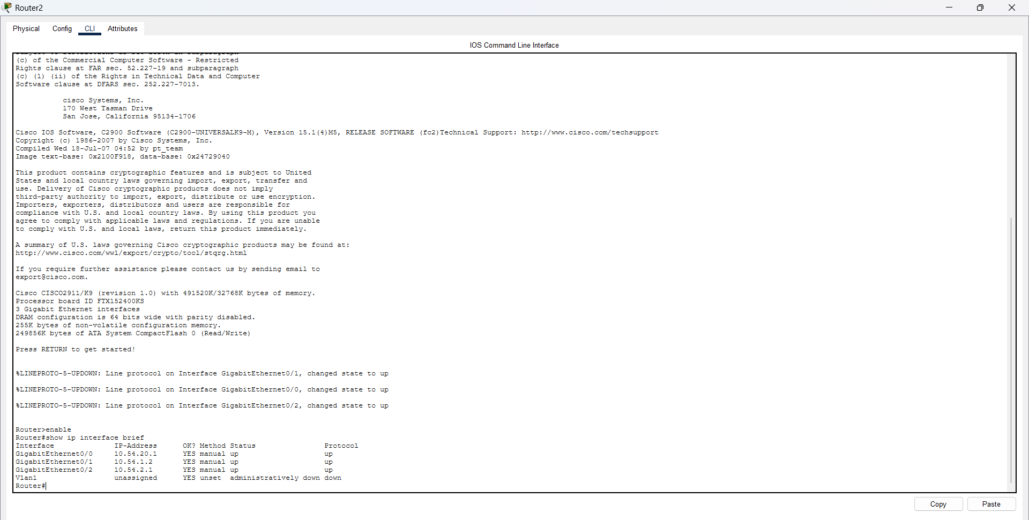

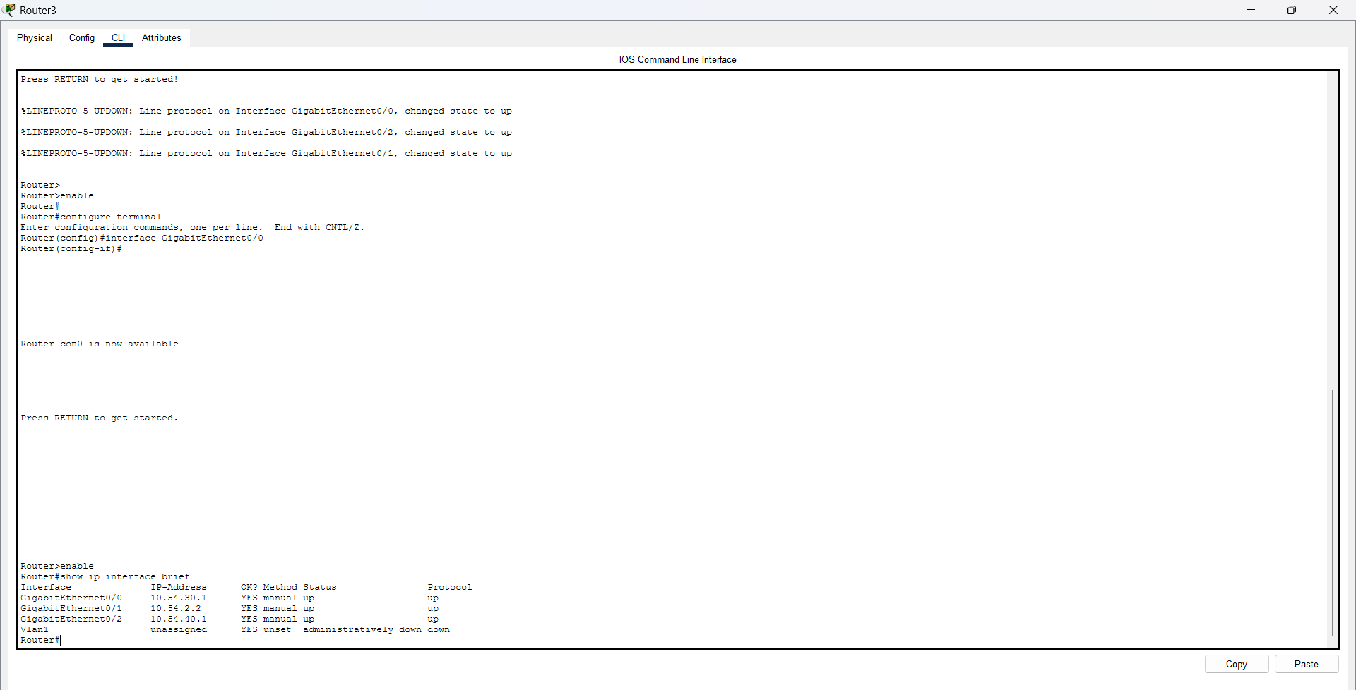

Figure 2-4 :Router interface status
STATIC ROUTING CONFIGURATION
Kgwebo IT services requirements was that static routing to control traffic movement between multiple routers should be implemented since it was a challenge before
STATIC ROUTING ON ROUTER 1
The configured routes for R1 are tabulated:
Next-Address | Destination network
10.54.1.2 | 10.54.40.0/24
10.54.1.2 | 10.54.30.0/24
10.54.1.2 | 10.54.20.0/24
STATIC ROUTING ON ROUTER 2
The configured routes for R2 are tabulated:
Next-Hop Address | Destination Network
10.54.1.1 | 10.54.10.0/24
10.54.2.2 | 10.54.40.0/24
10.54.2.2 | 10.54.30.0/24

STATIC ROUTING ON ROUTER 3
The configured routes for R2 are tabulated:
Next-Hop Address | Destination Network
10.54.2.1 | 10.54.20.0/24
10.54.2.1 | 10.54.10.0/24

Static routing set up was verified using the following command from CISCO IOS
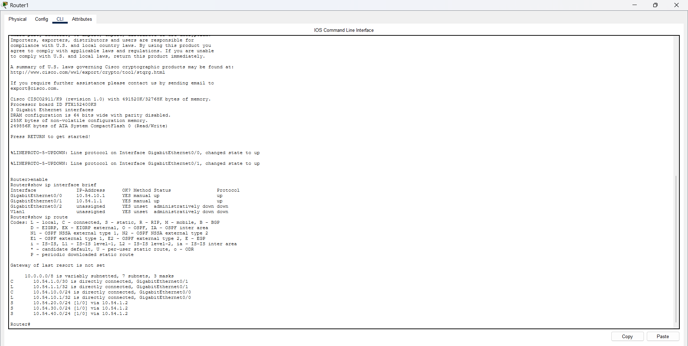
Show ip route

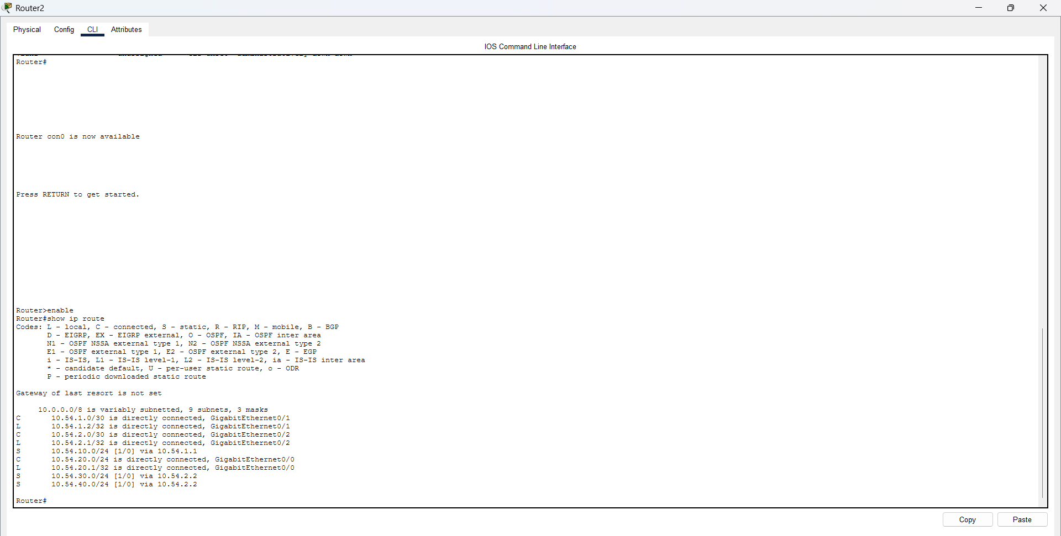

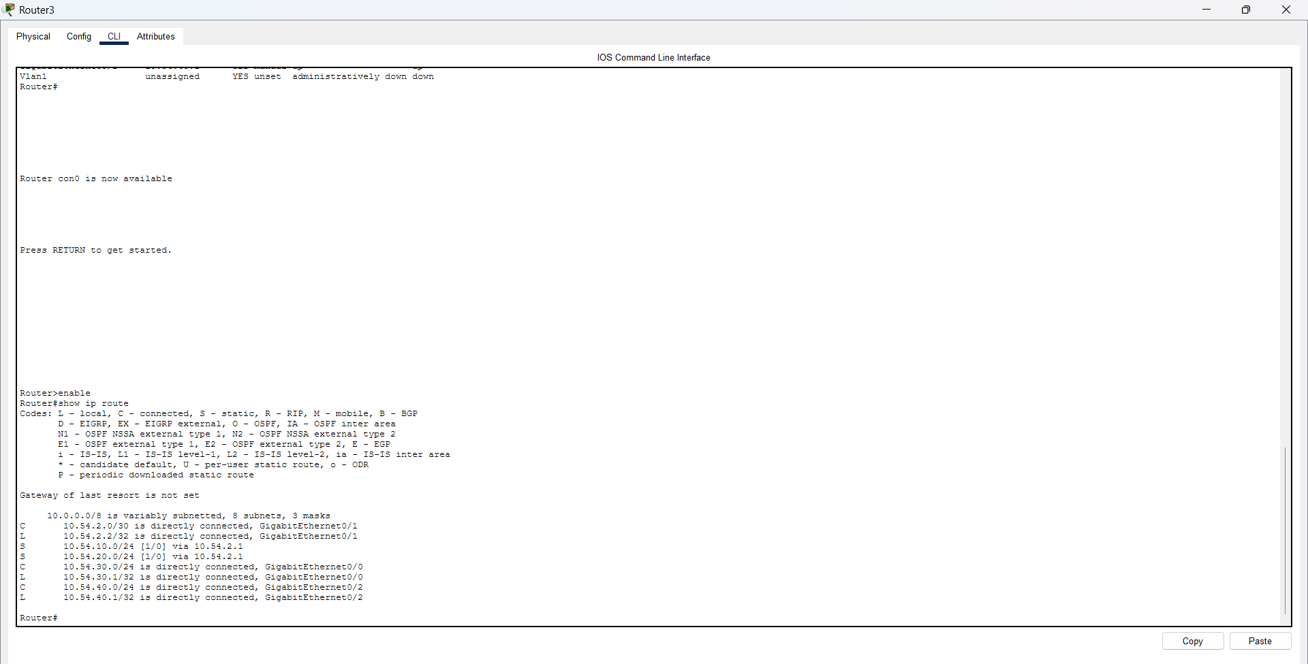

Figures 5-7: STATIC ROUTING TABLES FOR R1 R2 AND R3

APPLICATION/FILE SERVER
Kgwebo IT Services also requested a that the network should allow a new application file/server that would be accessible only to authorised departments

The tabulate information is about the server network settings:
Configuration | Value
Network | 10.54.40.0/24
Default GATE | 10.54.40.1
Subnet Mask | 255.255.255.0
Device | SERVER
IP Address | 10.54.40.10

The FTP service was activated on the server in Packet Tracer to simulate file-server function
With the Software Development department being the only one authorised to access the server.
SERVER ACCESS CONTROL SET UP
To restrict access to the server , an Extended Access Control List(ACL) was set up on router 3 and the ACL was assigned as number 100
The access policy is tabulated:
Source network | Department | Access to Server
10.54.30.0/24 | Software Dev | Allowed
10.54.20.0/24 | IT support | Blocked
10.54.10.0/24 | Admin | Blocked

ACCESS CONTROL LIST SET UP
The following commands were used during the set up
access-list 100 deny ip 10.54.20.0 0.0.0.255 host 10.54.40.10
access-list 100 deny ip 10.54.10.0 0.0.0.255 host 10.54.40.10
access-list 100 permit ip 10.54.30.0 0.0.0.255 host 10.54.40.10
while for server-facing interface were
ip access-group 100 out
interface GigabitEthernet0/2
Authorised Server Access Restriction Test
The following test was performed on Software dev pc 2 with the access being allowed “ping 10.54.40.10”

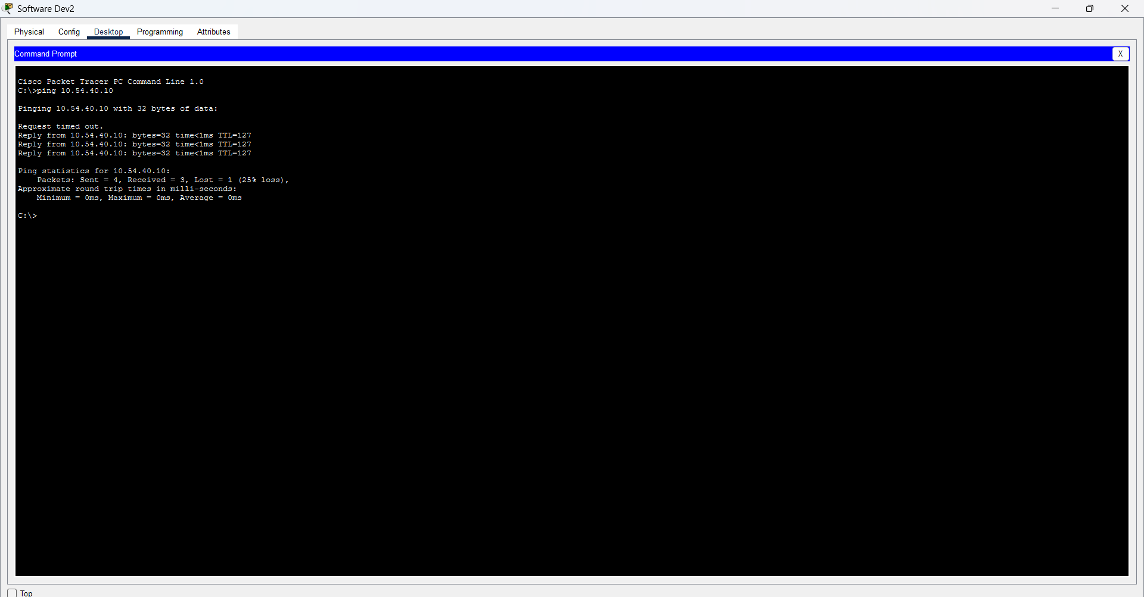

The following test was performed on Admin pc 1 with the access being blocked or denied.”ping 10.54..40.10”
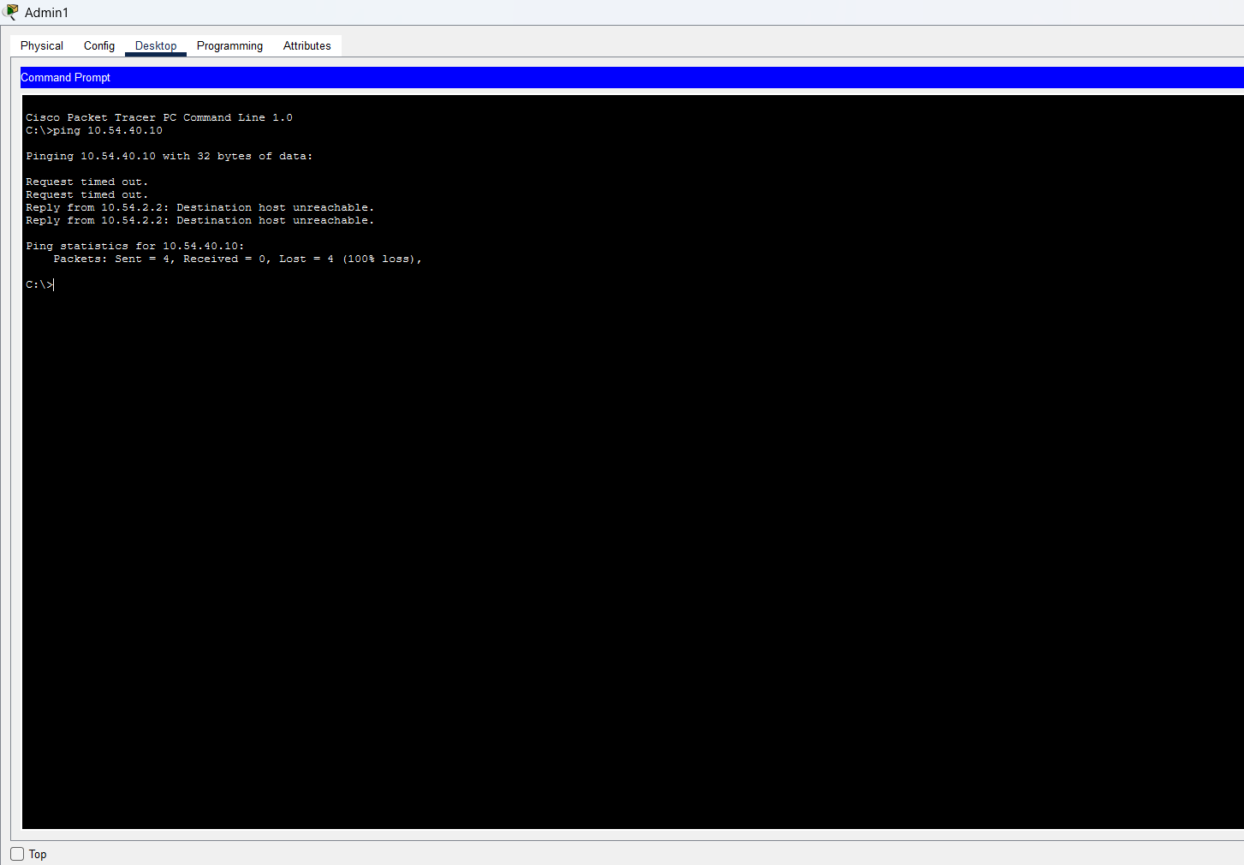

The following test was performed on IT support pc 2 with the access being blocked or denied ,”ping 10.54.40.10”
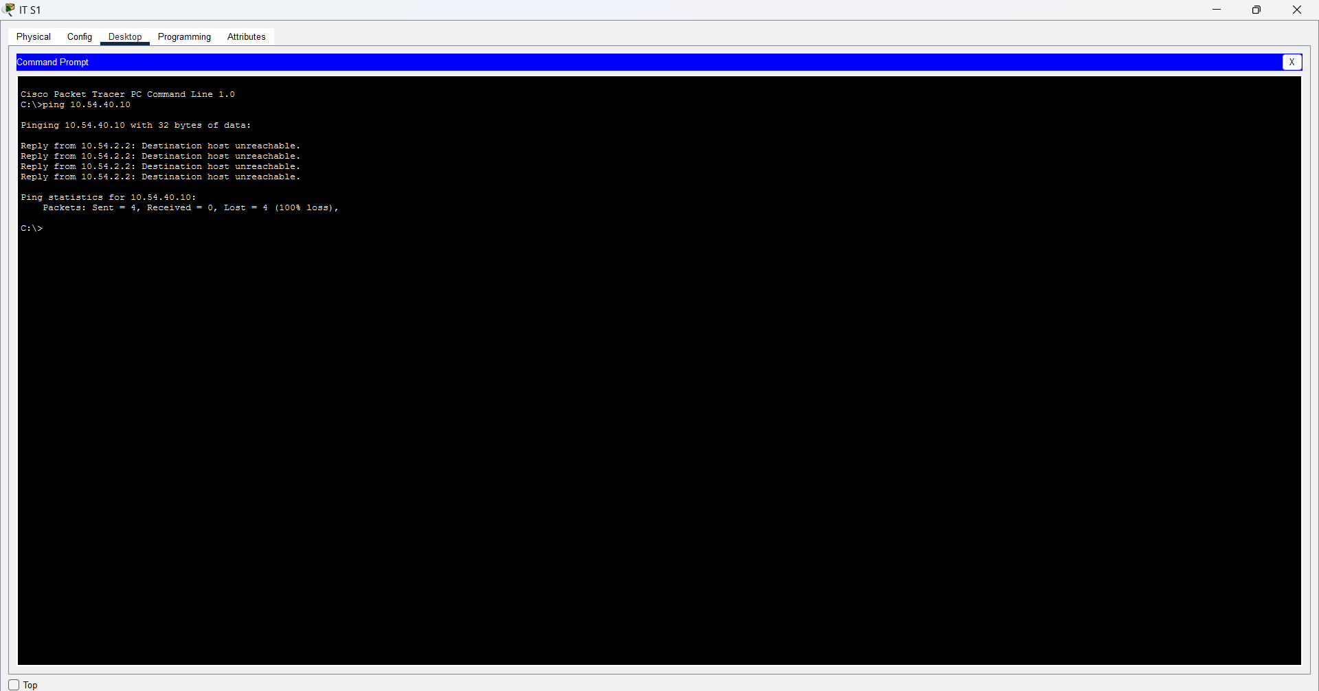

Additional evidence
Ping test Admin2
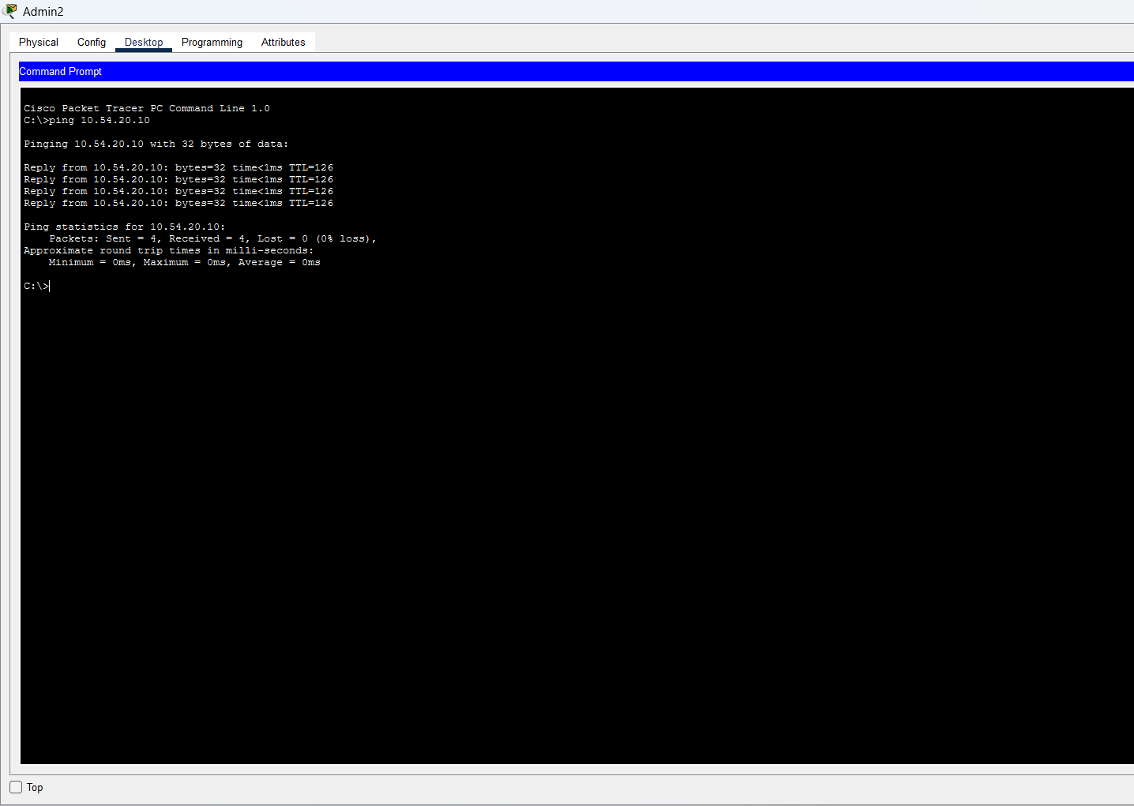
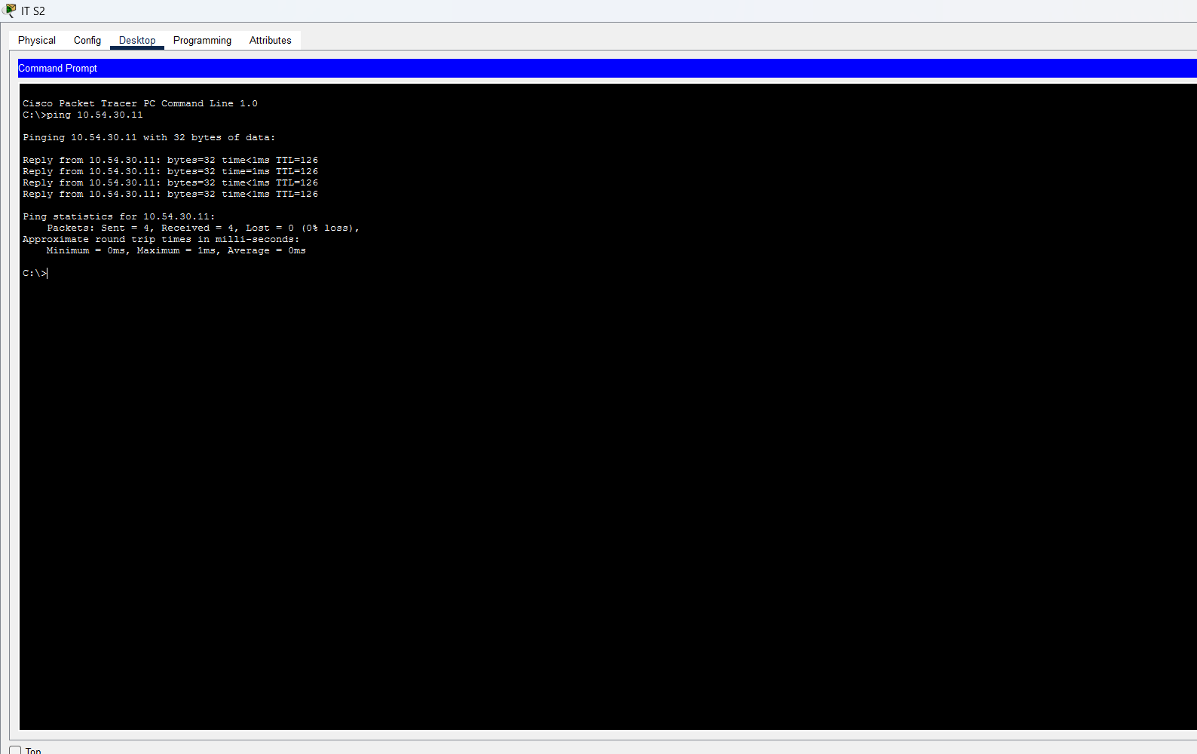
Ping test IT S2
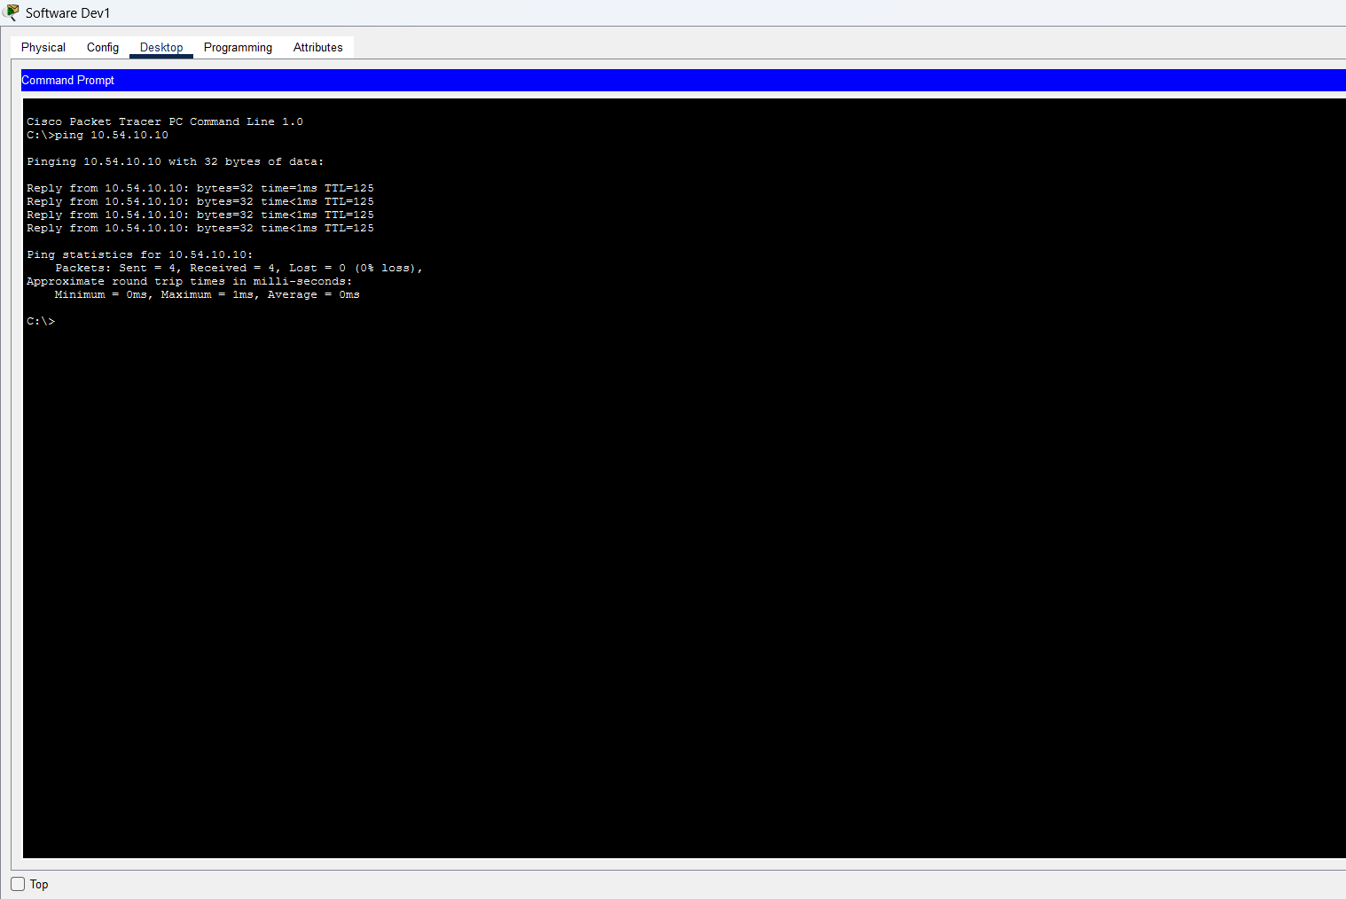
Ping Test Software Dev1
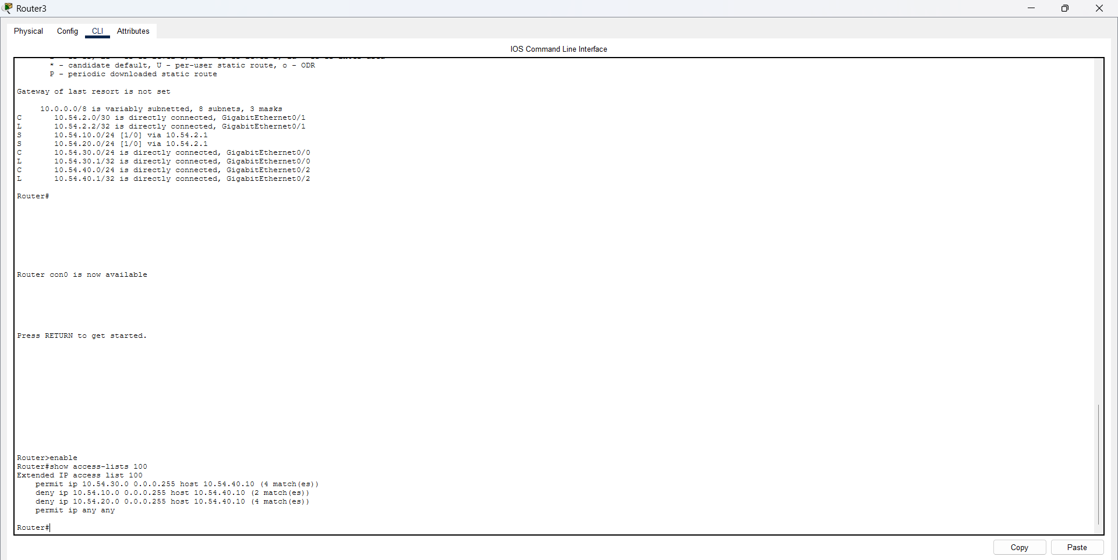
Access Control List
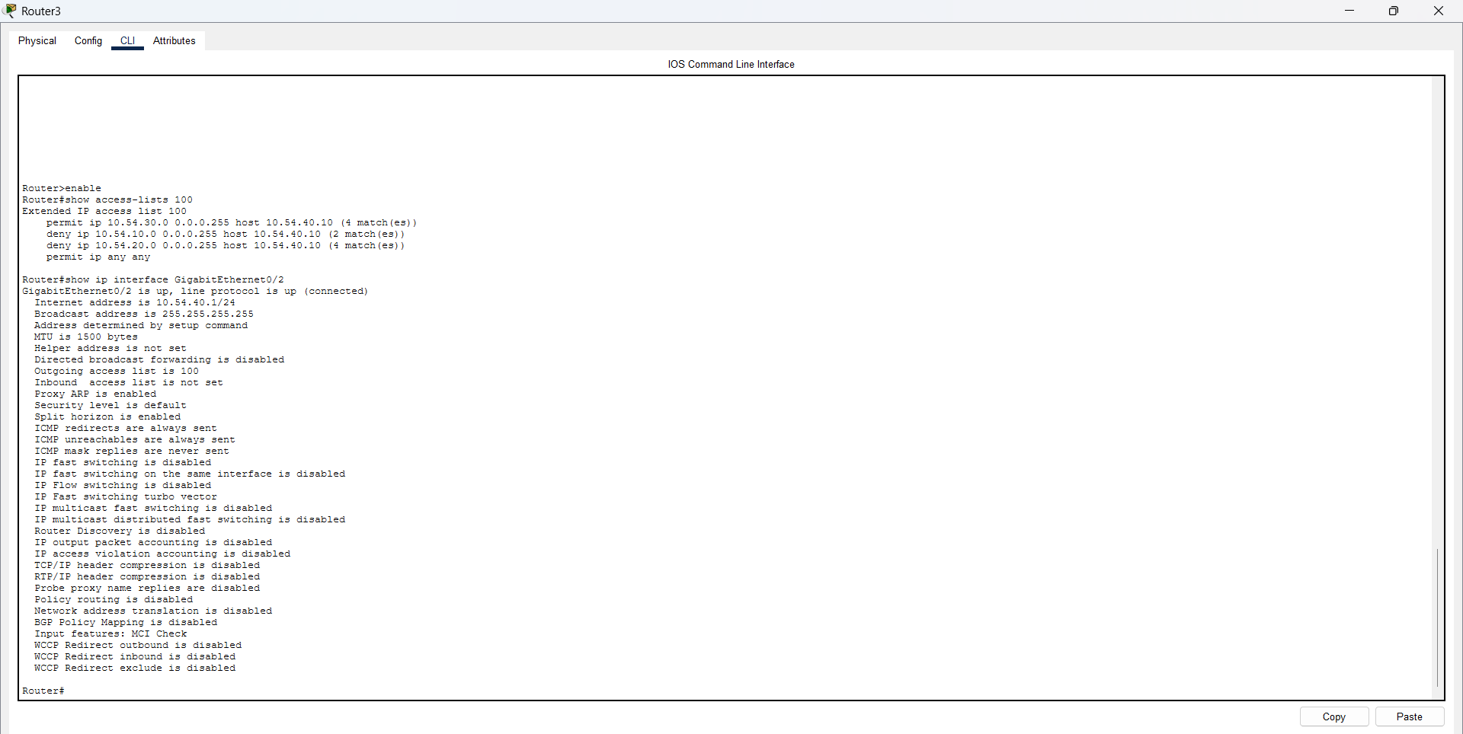
Access Control List Implemented on the server

Challenges and Troubleshooting
During the network implementation I encountered connectivity issues from wrong IP addresses, some interfaces were disabled, missing static routes and also being 1 PC from the Administration department not being able to ping the PCs in Software Dev department.
A systematic troubleshooting method was used, to identify the source of every issue. Interface status was checked first, then verifying the IP addressing and local gateway connectivity. Router-to-router connectivity was then tested and also the routing tables were also inspected to determine if the routes to remote network are present.

Conclusion
This document involved implementing the network infrastructure using CISCO PACKET TRACER
The implementation consisted of 3 2911 routers, 4 Switches, 6 PC’s and 1 application/file server. The IP addressing IN Milestone 1 was used and static routes were set up on all three routers
The application/file server was set up on the 10.54.40.0/24 network. Testing verified that the relevant router interfaces were functioning properly ,static routes were there in the routing tables, authorised server connectivity was successful and unauthorised server access was blocked.
The CISCO PACKET TRACER file is uploaded for more testing evidence.
The results demonstrated that requirements from KGWEBO IT Services were achieved, even though I used the subnets for the given addressing block the 10.54.0.0/16 IPv4 addressing plan was implemented, the departmental gateways and router interfaces were set up, the static routes allowed communication across all the departments, the server access restriction where only authorised departments can access was achieved as well. Future improvements could include moving to dynamic routing protocol that will enhance network resilience

REFERENCING
1. Cisco Systems. CISCO PACKET TRACER. Available at: https://www.netacad.com/cisco-packet-tracer (Accessed: [2026/09/15]
2. Cisco Systems. CISCO IOS DOCUMENTAION. Available at: https://www.cisco.com/c/en_za/support/index.html (Accessed [2026/09/24]
3. North-West University Module CMPG325 notes and the project assignment brief [2026/09/15]

